JOIN COMMANDS

SELECT \*FROM EMPLOYEE;

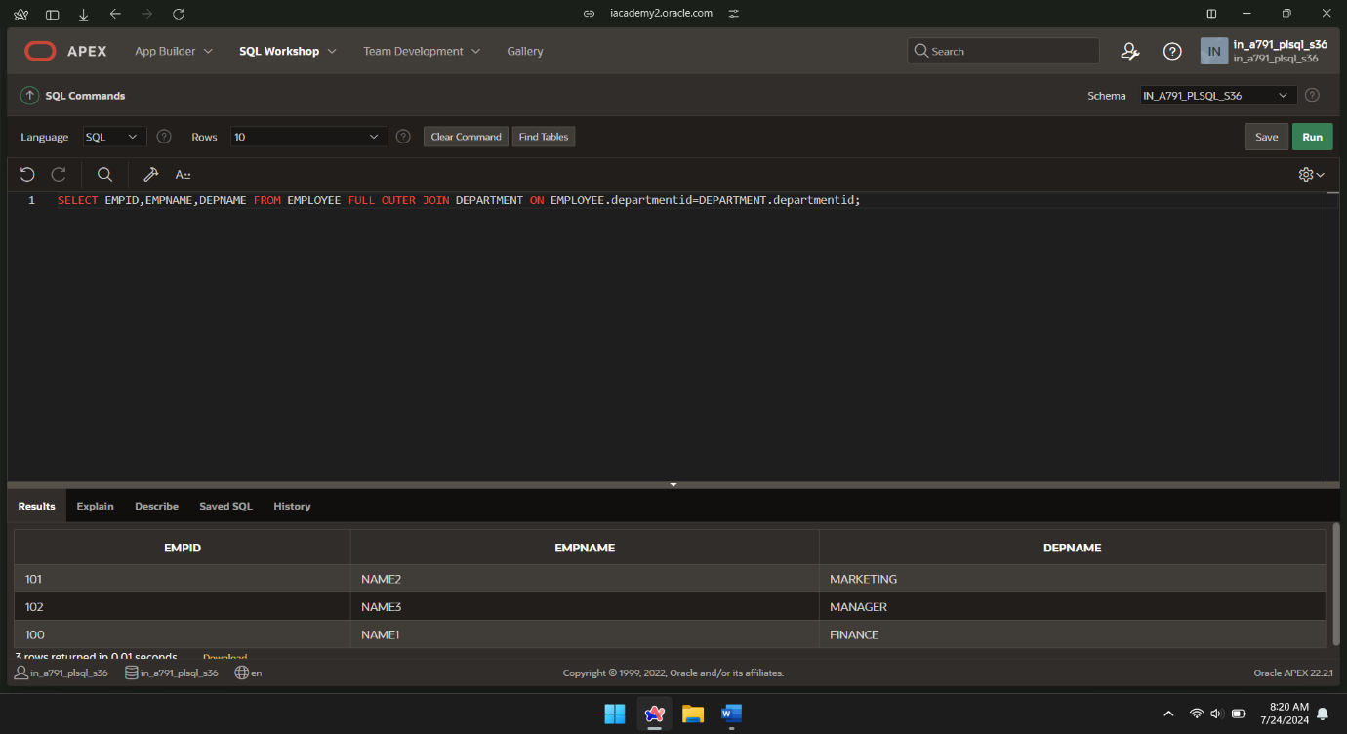

SELECT \*FROM DEPARTMENT;

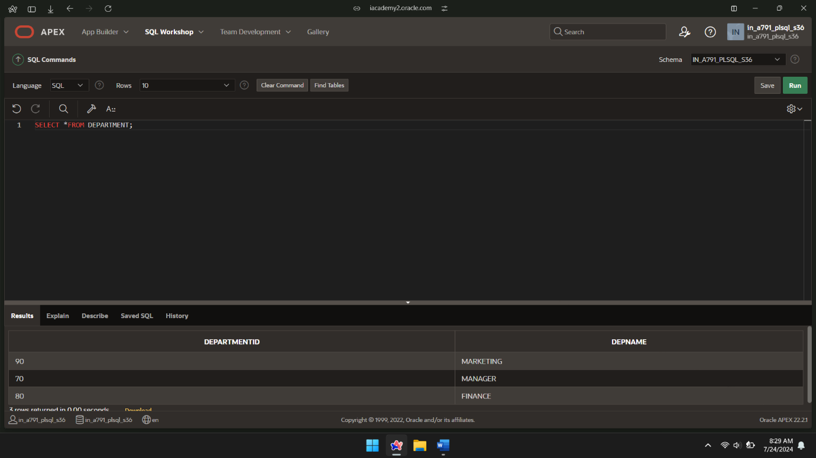

SELECT EMPID,EMPNAME,DEPNAME FROM EMPLOYEE NATURAL JOIN DEPARTMENT;

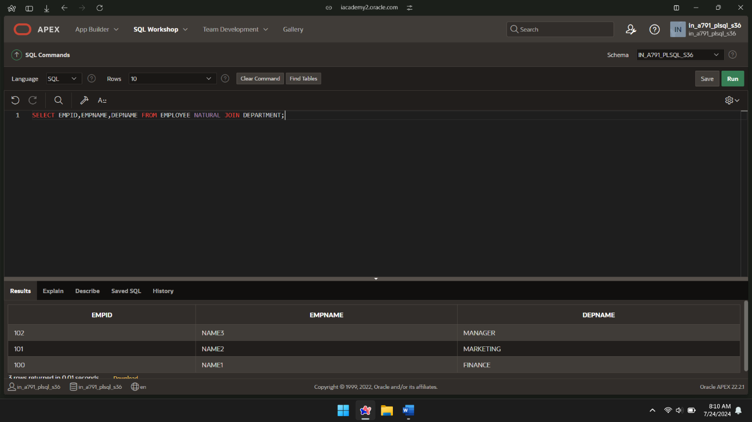

SELECT e.EMPID,e.EMPNAME FROM EMPLOYEE e JOIN DEPARTMENT D USING(departmentid);

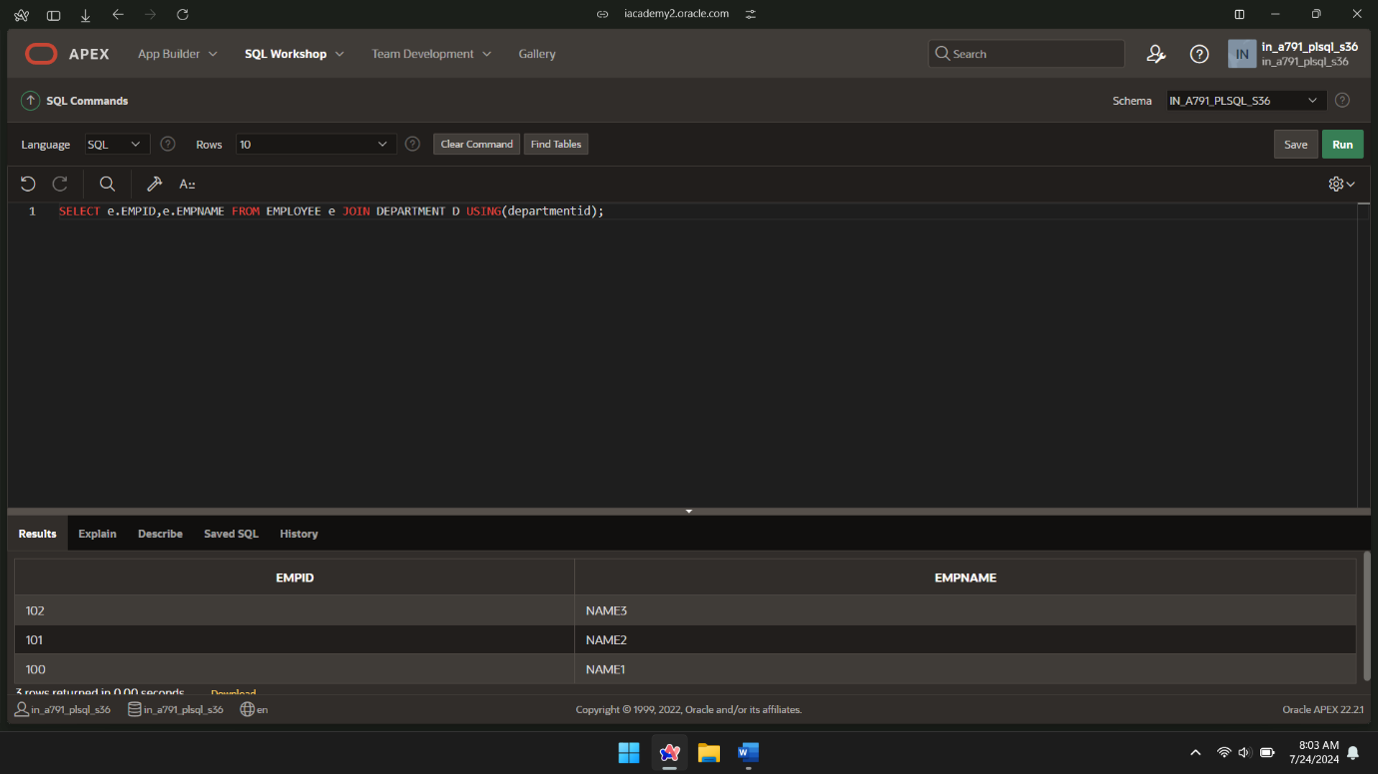

SELECT EMPLOYEE.empid,DEPARTMENT.departmentid FROM EMPLOYEE LEFT JOIN DEPARTMENT ON EMPLOYEE.departmentid=DEPARTMENT.departmentid;

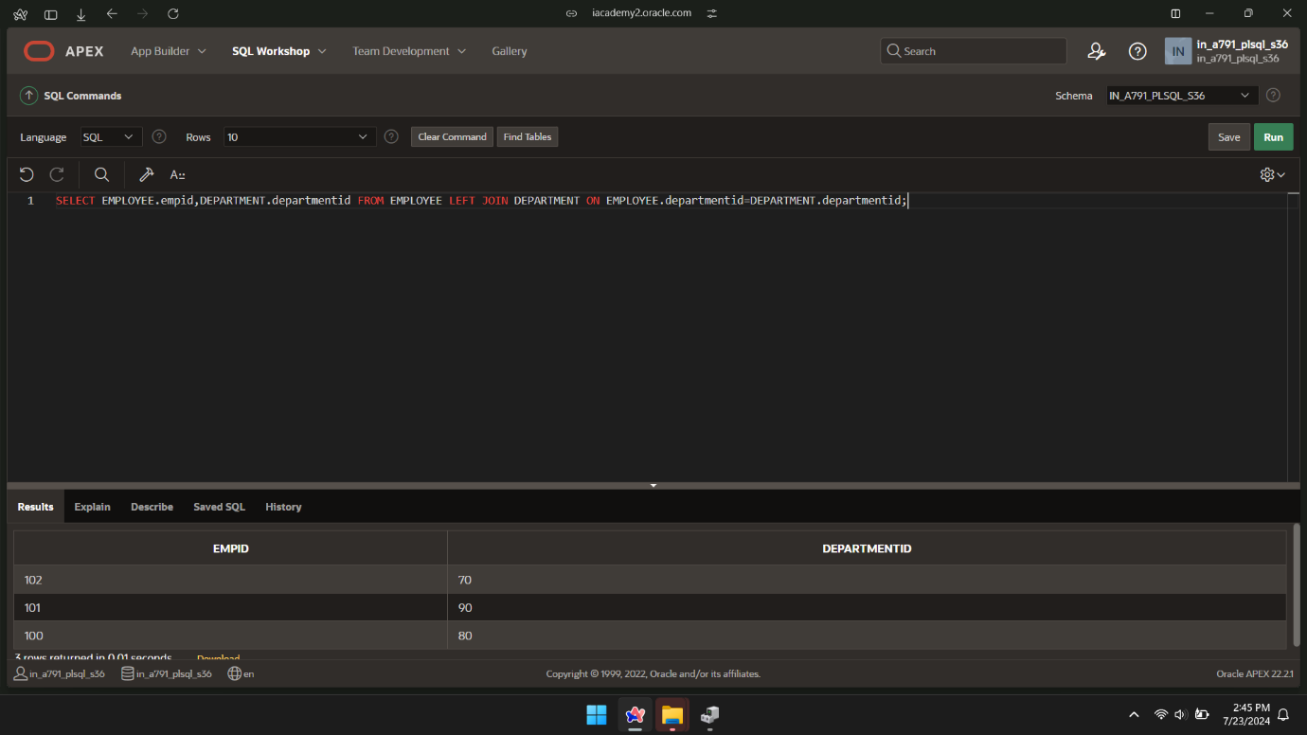

SELECT EMPID,EMPNAME,DEPNAME FROM EMPLOYEE RIGHT JOIN DEPARTMENT ON EMPLOYEE.departmentid=DEPARTMENT;

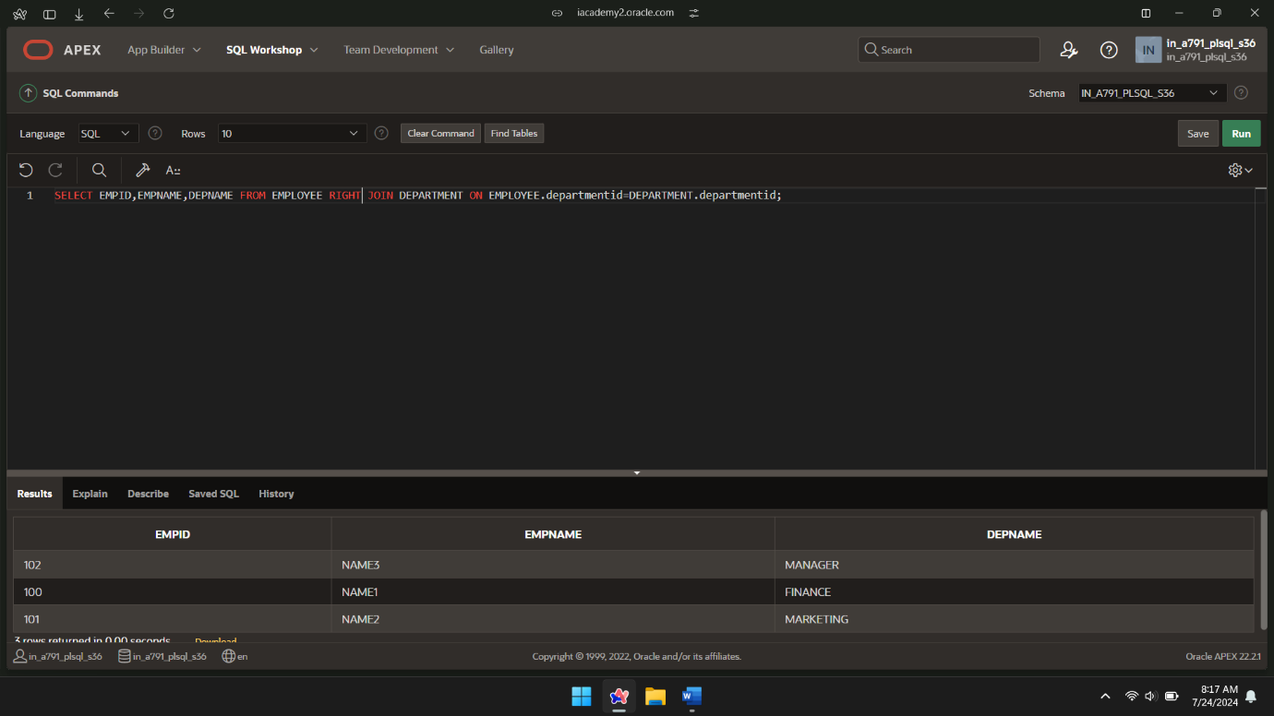

SELECT EMPID,EMPNAME,DEPNAME FROM EMPLOYEE INNER JOIN DEPARTMENT ON EMPLOYEE.departmentid=DEPARTMENT.departmentid;

